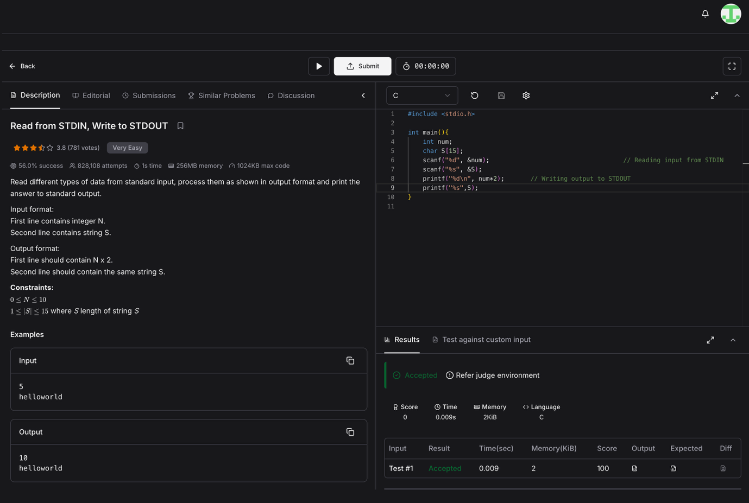
Problem link: https://www.hackerearth.com/practice/basic-programming/input-output/basics-of-input-output/practice-problems/algorithm/io-exercise/?tab=description

#include <stdio.h>

int main(){
int num;
char S[15];
scanf("%d", &num); // Reading input from STDIN
scanf("%s", &S);
printf("%d\n", num*2); // Writing output to STDOUT
printf("%s",S);
}

